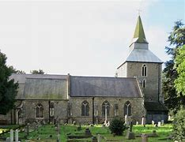
DISTRICT OF SOUTH ESSEX - ROSE CROIX

V.Ill. Bro. John Hubbard, 33º invites you to
St. Laurence Church,
Parish Church of Upminster RM14 2BB
On Sunday 17th October 2021 at 4.00pm.
For our ANNUAL SERVICE OF EVENSONG

APPLICATION FOR REFRESHMENTS FOLLOWING THE SERVICE.

To be held at Upminster Masonic Hall, Deyncourt Gardens – Cost £9.00 per person.

To: E.C. Terry, 34 Bramley Way, Mayland, Chelmsford, CM3 6ER. Tel No 01621 740906

Number of buffets required ___________ Payment is by (* delete as applicable)
* Cheque for the sum of £ ________ payable to “A. & A. Rite District of South Essex”

* Bank transfer for the sum of £ ________ to A & A Rite. HSBC 40-45-31 Account 21385291
(Please use your surname as reference and email completed form to eric.terry2@gmail.com)

Names 1) ____________________________ 2) ____________________________
3) ____________________________ 4) ____________________________
5) ____________________________ 6) ____________________________
Contact telephone number_________________
PLEASE APPLY BY NO LATER THAN Friday 8th October 2021

